
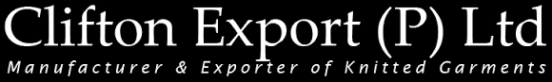


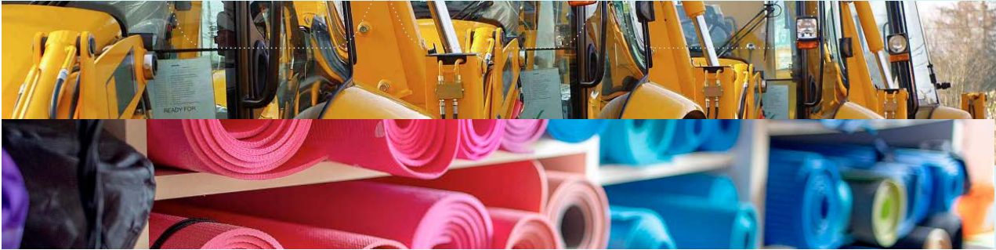
Rev No: 02
Effective Date: 01/04/2024
Last Review Date: 01/04/2025
Next Review Date: 01/04/2026
LABOUR & HUMAN RIGHTS
POLICY

TABLE OF CONTENTS
INTRODUCTION 2
SCOPE 2
POLICY STATEMENT 2
PRIORITY AREA 4
AIMS 6
CRITICAL BENCHMARKS 8
SDGs Covered 9
REPORTING 10
CONTINUOUS IMPROVEMENT 11
REVIEW MECHANISM 11
ACKNOWLEDGMENT 12

INTRODUCTION
At Clifton Export(P) Ltd., we assume a pivotal role in advancing sustainable and responsible business practices. Our steadfast commitment to Environmental, Social, and Governance (ESG) principles is encapsulated within our Social Responsibility Policy, serving as a guiding framework steering our operations towards achieving a harmonious balance between economic success and social and environmental well-being.
Central to our organizational ethos is an unwavering dedication to upholding workers' rights and ensuring optimal working conditions. We firmly believe that a healthy and empowered workforce is not only integral to our success but is also imperative for sustainable growth. Our relationships with stakeholders are built on the foundational pillars of transparency, engagement, and mutual respect.
We are dedicated to the principles of equal opportunity and the cultivation of diversity, equity, inclusion, and belonging (DEIB). Our commitment involves a deliberate effort to construct a more diverse, equitable, and inclusive community within Clifton Export(P) Ltd., fostering an environment where every individual can prosper. This commitment extends to creating a culture where all voices are heard, individuals can authentically express themselves, and a profound sense of belonging is instilled.
We firmly believe that by integrating diversity, equity, and inclusion into the very fabric of our business and talent practices, we enhance our collective creativity, innovation, and personal development. Every person's distinctive background, identity, and experiences are not only acknowledged but also highly valued and appreciated in our inclusive environment.

SCOPE
This Policy is applicable to following sites and all of its employees, workers, sub-contractors and other stakeholders:
Sr. No. | Site | Address
1 | Clifton Export (P) Ltd | 108/3E, Sedapalayam Road, Arulpuram - P.O, Palladam Taluk,Tirupur - 641605, Tamilnadu, India

POLICY STATEMENT
Clifton Export(P) Ltd. firmly believes that by integrating diversity, equity, and inclusion into the very fabric of our business and talent practices, we enhance our collective creativity, innovation, and personal development. Every person's distinctive background, identity, and experiences are not only acknowledged but also highly valued and appreciated in our inclusive environment.

PRIORITY AREA
Employee Health & Safety
- Safe Knitting Operations: Develop and regularly review safe operating procedures (SOPs) for knitting machines to ensure the well-being of employees in the Knitting division.
- Chemical Management in Dyeing Processes: Enforce strict guidelines for the proper handling, storage, and disposal of chemicals used in dyeing processes to mitigate health risks for employees.
- Ergonomic Workstations in Garment Stitching: Design and maintain ergonomic workstations in the Stitching division to minimize the risk of repetitive strain injuries.
- Ventilation in Dyeing and Finishing Divisions: Install and maintain effective ventilation systems, especially in dyeing, printing, and finishing divisions, to control exposure to fumes and ensure a healthy work environment.
Working Conditions
- Adherence to Legal Working Hours in Garment Stitching: Align working hours in garment stitching with legal regulations while considering the unique demands of knitted garment production cycles.
- Facilities and Amenities for Garment Manufacturing: Provide facilities that address the challenges of manufacturing knitted garments, including rest areas, ventilation, and facilities for personal hygiene.
Social Dialogue
- Communication Channels: Evaluate and enhance communication channels for employees involved in garment production to express concerns, suggestions, or feedback.
- Transparent Grievance Resolution in Operations: Develop a transparent grievance resolution process that encourages open dialogue, addresses concerns promptly, and fosters a culture of trust and mutual respect within divisions handling.
Career Management
- Knitted Garment Skill Enhancement Programs: Provide ongoing training programs to enhance the technical skills of employees.
- Cross-Training Opportunities in Knitted Garment Processes: Facilitate cross-training opportunities to broaden employees' skill sets in various processes related to knitted garment production.
Child or Forced Labor
- Zero Tolerance for Child or Forced Labor: Reiterate the zero-tolerance policy for any form of child labor or forced labor within knitted garment operations.
- Age Verification while Hiring: Implement robust age verification procedures during the hiring process to ensure all employees involved in operations are of legal working age.
- Provide training programs to educate employees and management in operations about the prohibition of child labor and forced labor.
- Supply Chain Monitoring: Regularly monitor and evaluate the supply chain to ensure that suppliers and subcontractors also comply with the child and forced labor policy.
Diversity and Discrimination
- Foster an atmosphere of open and candid communication in divisions handling knitted garments where different ideas, perspectives, and beliefs are respected and encouraged, while strictly prohibiting any form of harassment and discrimination to ensure a safe and inclusive workplace.
- Implement and promote diversity initiatives in operations by examining whether they lead to a more inclusive and diverse workforce, while also enforcing policies that prevent harassment and discrimination based on race, gender, age, religion, disability, or other characteristics.
External Stakeholder and Human Rights
- Assessing Impact on Local Communities: Conduct a comprehensive assessment of the impact of operations on local communities through interviews and discussions with community members.
- Collaboration with NGOs in Human Rights Initiatives: Evaluate the effectiveness of collaboration with human rights-focused non-governmental organizations (NGOs) and the positive impact on external stakeholders.

AIMS

Employee Health & Safety
- Conduct specialized training sessions for employees on safe knitting operations and chemical handling in dyeing processes by 2027.
- Provide employees in stitching divisions with appropriate ergonomic workstations to prevent musculoskeletal disorders.
- Develop a comprehensive respiratory health program by 2027, especially focusing on employees in dyeing and finishing divisions.
Working Conditions
- Provide safe water for drinking and rest areas with good amenities in various parts of the manufacturing and operations.
- Implement flexible scheduling to accommodate peak production demand for and prevent worker fatigue.
- Regularly assess the condition of facilities by conducting regular audits and address maintenance needs promptly.
Social Dialogue
- Increase the percentage of employees involved in garment production participating in social dialogue forums and meetings.
- Develop a transparent grievance resolution process specific to knitted garment challenges by 2027.
Career Management
- Implement a mentorship program tailored for career development in knitted garment production by providing guidance, skill-building opportunities, and a clear path for advancement within the organization.
- Implement cross-training programs in processes related to knitted garment production with a focus on collaboration and knowledge exchange.

Child or Forced Labor
- Ensure 100% transparency in the supply chain for knitted garments regarding child or forced labor practices and eradicate any occurrences of child or forced labor by 2027.
- Institute a zero-tolerance policy for suppliers involved in child or forced labor in processes related to knitted garment production and establish a transparent reporting mechanism by 2027.
Diversity and Discrimination
- Conduct regular diversity audits in knitted garment operations to identify areas for improvement and track progress, ensuring that the workplace continually evolves to promote inclusivity, equal opportunities for all employees, and a zero-tolerance policy against harassment and discrimination.
- Ensure that company policies and practices actively promote equal opportunities for all employees involved in knitted garment production, fostering a fair and inclusive work environment where everyone has the chance to succeed, free from any form of harassment.
- Measure the percentage of employees involved in knitted garment production who complete diversity and inclusion training, ensuring that all team members are equipped with the knowledge to contribute to a respectful, harassment-free, and inclusive workplace.
External Stakeholder and Human Rights
- Communicate transparently with stakeholders about the company's commitment to human rights in knitted garment operations, regularly publishing reports on initiatives, progress, and challenges.
- Track the implementation and results of human rights due diligence processes specific to knitted garment operations.

CRITICAL BENCHMARKS
Below are our commitments and targets towards environmental sustainability, benchmarked against the baseline year 2022, with a target year of 2027.
Employee Health & Safety
- Establish and conduct health and safety training program tailored in every 3 months for knitted garment processes by 2027.
- Achieve 100% employee participation in emergency response drills specific to knitted garment challenges by 2027.
- Provide ear protective gear to employees in high-noise areas in the Knitting division.
Working Conditions
- Enhance ventilation and lighting conditions by 15% in designated areas for knitted garment production by reviewing working conditions across all departments and addressing identified issues by 2027.
- Improve overall work-life balance for employees involved in knitted garment production by 10% by 2027.
- Achieve a 20% increase in employee satisfaction with working conditions within the next year (2027).
Social Dialogue
- Establish regular communication channels between management and employees involved in knitted garment production, targeting a 15% improvement in employee satisfaction by 2027.
- Successfully negotiate and conclude a mutually beneficial collective bargaining agreement with knitted garment employee representatives by 2027.
Career Management
- Achieve a 15% increase in the average skill proficiency of employees across all divisions involved in knitted garment production within the next year.
- Implement a performance management system in divisions handling knitted garments to provide regular feedback and development opportunities, leading to a 10% increase in employee promotions by 2027.
- Increase cross-functional competence in divisions handling knitted garments by 10% through cross-training initiatives within the next year.

Child or Forced Labor
- Conduct an extensive audit of the supply chain to identify and eliminate any instances of child or forced labor by 2027.
- Implement a zero-tolerance policy for suppliers engaging in child or forced labor, and establish a transparent reporting mechanism by 2027.
Diversity and Discrimination
- Enhance workforce diversity in knitted garment operations by 15% through focused recruitment initiatives and inclusive hiring practices by the year 2027, while ensuring strict measures are in place to prevent harassment and discrimination, promoting a safe and inclusive work environment for all employees.
- Execute diversity and inclusion training programs for all employees involved in knitted garment production, striving for a 20% increase in awareness and understanding by 2027, while integrating harassment prevention and respect for all individuals into the core of the training.
External Stakeholder and Human Rights
- Conduct a human rights impact assessment on external stakeholders in knitted garment operations, addressing identified issues and implementing improvements by 2027.
- Achieve partnerships with external organizations representing at least 20% of the broader knitted garment community by 2027.

SDGs Covered
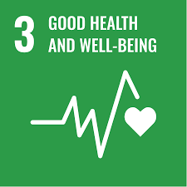
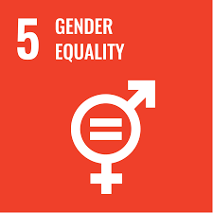
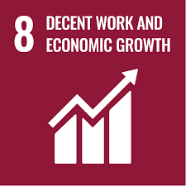
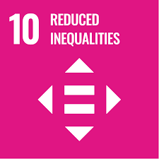


REPORTING
Clifton Export (P) Ltd. remains steadfast in its commitment to transparency, accountability, and continuous improvement of its Environmental, Social, and Governance (ESG) principles within its operational framework, specifically addressing challenges in the knitted garment manufacturing process. To ensure a thorough comprehension of our current standing and identify opportunities for future enhancement, we have established a robust reporting mechanism comprising the following key components:
Monitoring and Audit Reports for Garments: Regular reporting derived from internal monitoring, audits, and external assessments specifically aimed at evaluating and documenting our performance concerning social responsibility. These reports will provide a detailed overview of our adherence to established standards and highlight areas for enhancement in the context of knitted garment manufacturing.
Employee Feedback and Health Surveys in Operations: Implementation of health surveys tailored for manufacturing, focusing on respiratory system-related diseases and feedback mechanisms to assess the effectiveness and impact of our labor and human rights initiatives. This invaluable input will enable us to assess employee satisfaction, pinpoint areas of concern specific to knitted garment processes, and customize our strategies for continuous improvement.
External Stakeholder Communication Records for Initiatives: Maintenance of comprehensive records detailing our communication with external stakeholders, particularly in the context of knitted garment manufacturing. This includes our social responsibility initiatives, partnerships, and collaborations specific to Knitting, Dyeing, Elastic, Embroidery, Stitching, Printing, and Finishing divisions. This repository will serve as a testament to our commitment to engaging with external entities and fostering collaboration to drive positive social and environmental change within the knitted garment industry.
Legal and Regulatory Compliance Documents & Processes: Thorough documentation aimed at showcasing our steadfast adherence to pertinent local, national, and international laws and regulations pertaining to social responsibility, with a specific focus on knitted garment manufacturing. These documents serve to emphasize our commitment to ethical practices and ensure alignment with legal frameworks, thereby upholding the highest standards within our operations related to Knitting, Dyeing, Elastic, Embroidery, Stitching, Printing, and Finishing divisions.

CONTINUOUS IMPROVEMENT
To ensure the ongoing relevance and effectiveness of this policy, a comprehensive review will be conducted after one year. This review will consider changes in environmental laws, technological advancements, and the evolving needs of our stakeholders. The responsibility for this annual review is assigned to the Environment, Social, and Governance (ESG) Team, consisting of representatives from key departments within the organization.

The ESG Team's mandate is to thoroughly evaluate the implementation of the policy, assess the achievement of established targets, and recommend adjustments or enhancements to align with emerging environmental standards and best practices. Their collective expertise ensures a holistic perspective in addressing evolving challenges and opportunities.

The final approval of any adjustments to the policy will be granted by the CEO of Clifton Export (P) Ltd This ensures the highest level of leadership endorsement for our environmental initiatives, emphasizing the organization's commitment to sustainability and responsible business practices. This systematic review process underscores our dedication to staying abreast of developments in the environmental landscape and continuously improving our policies to meet the highest standards.

REVIEW MECHANISM
This policy will undergo an annual review to track progress on each issue and its targets. The evaluation will be conducted by representatives from key departments within the organization, ensuring a comprehensive assessment of our environmental initiatives. Any necessary adjustments or enhancements will be recommended based on the outcomes of this annual review.

REV. No. 02

EFFECTIVE FROM: 01.04.2024 NEXT REVIEW DATE: 01.04.2026
LAST REVIEW DATE: 01.04.2026

APPROVED BY: PRESIDENT – OPERATIONS

ACKNOWLEDGMENT
I, _________________________, as an employee of Clifton Export (P) Ltd., acknowledge that I have read, understood, and agree to comply with the company’s Labor and Human Rights Policy. I recognize my responsibility as an employee to uphold and support the principles of human dignity, equality, and fair treatment for all individuals in the workplace.

As an employee, I am committed to promoting and maintaining a work environment that is free from discrimination, harassment, child labor, forced labor, and any form of exploitation. I will respect the rights of all colleagues and workers, support freedom of association, and contribute to a safe, healthy, and inclusive workplace.

I understand that my actions as an employee play a critical role in helping Clifton Export (P) Ltd. meet its labor and human rights commitments. I am dedicated to acting in alignment with the company’s values and reporting any concerns or violations through the appropriate channels.

Employee Signature:
Employee Name:
Designation:
Date: _____________________________

